VALEKOR
DEVELOPER LIBRARY 051
THE SACRED CITADEL
The Last Refuge of the Free Kingdoms
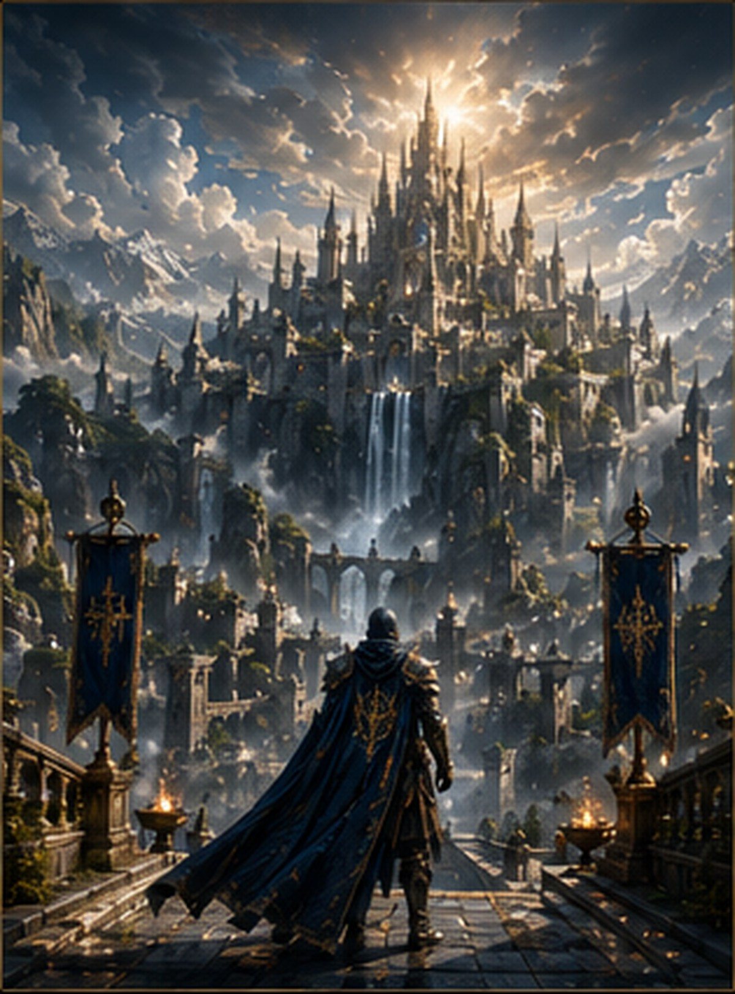

Prologue - The Bells Return
The first bell rang before sunrise. Its sound crossed the Frozen Mountains, descended through valleys abandoned since the Great War, and reached settlements that had never heard the name of the Sacred Citadel.
For centuries, the fortress had remained silent behind clouds, waterfalls, and ancient wards. Its towers were visible only to those summoned by the Eternal Flame. On the morning the Last Guardian left the Sanctuary of Eternity, the Citadel awakened.
Five lights appeared across the horizon. Each carried a different color, yet all moved toward the same destination. The free kingdoms understood the warning: the age of hiding was over.

Chapter I - The Last Refuge
The Sacred Citadel was built after the fall of the Guardian Order. Survivors from seven shattered strongholds gathered in the Celestial Mountains carrying fragments of lost archives, broken weapons, and the names of those who had died.
They did not build a palace. They built a refuge. Every tower served a purpose: observation, healing, research, defense, or remembrance. Water from the mountain glaciers powered the lower forges, while crystals beneath the central keep amplified protective magic around the valley.
No single kingdom owned the Citadel. That rule became its first law. The fortress belonged to every free people willing to defend Valekor.

Chapter II - The Celestial Gates
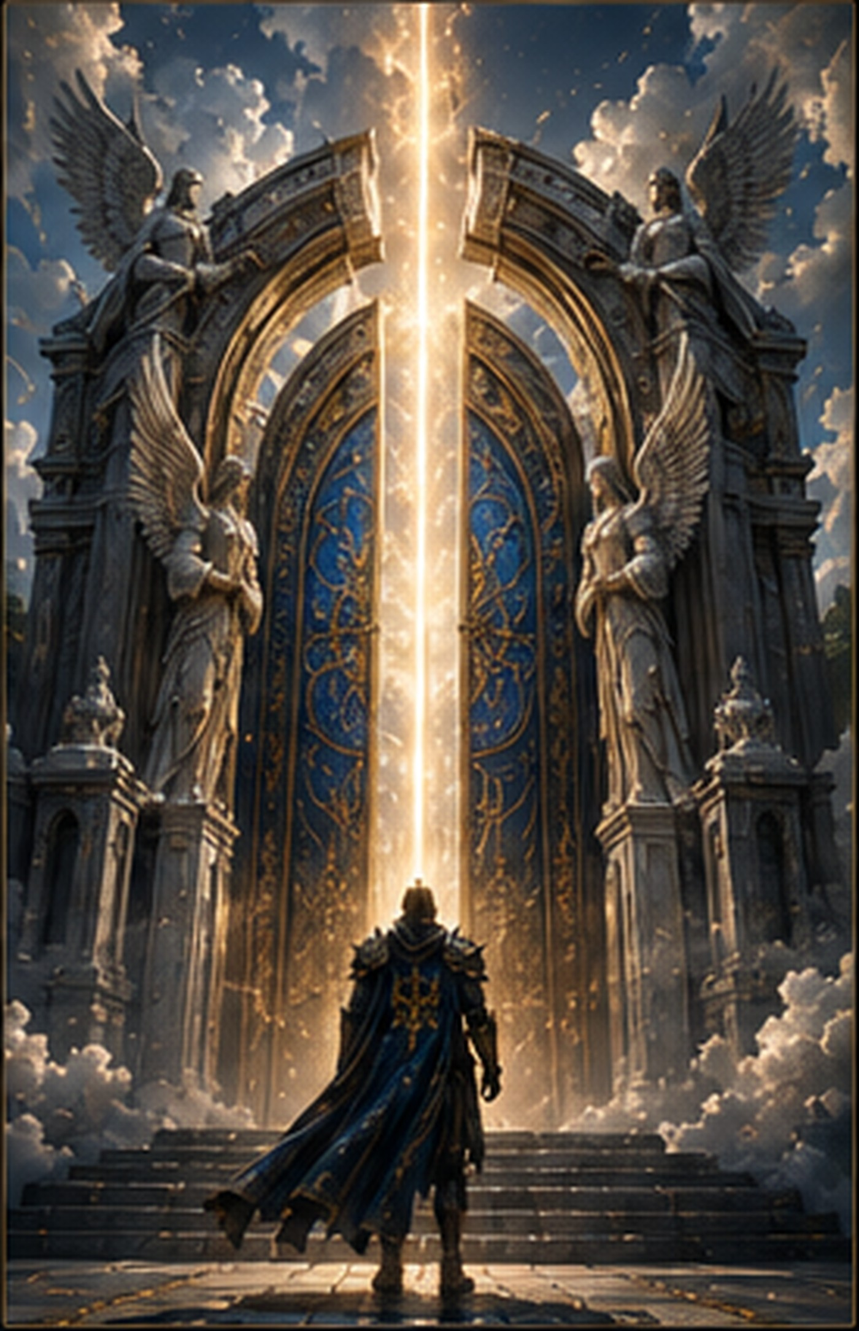
The Celestial Gates rose higher than the walls of most kingdoms. Two winged statues guarded their entrance, representing courage and mercy. Between them ran a vertical line of golden light that responded only to the ancient Guardian oath.
For generations the gates remained sealed. Armies searched for them and found only cliffs. Spies approached and became lost in endless fog. Those called by the Eternal Flame, however, always discovered a path.
When the five chosen arrived, the light divided into five beams. The doors opened without a sound, revealing a road of white stone leading toward the heart of the Citadel.

Chapter III - The Council of Light
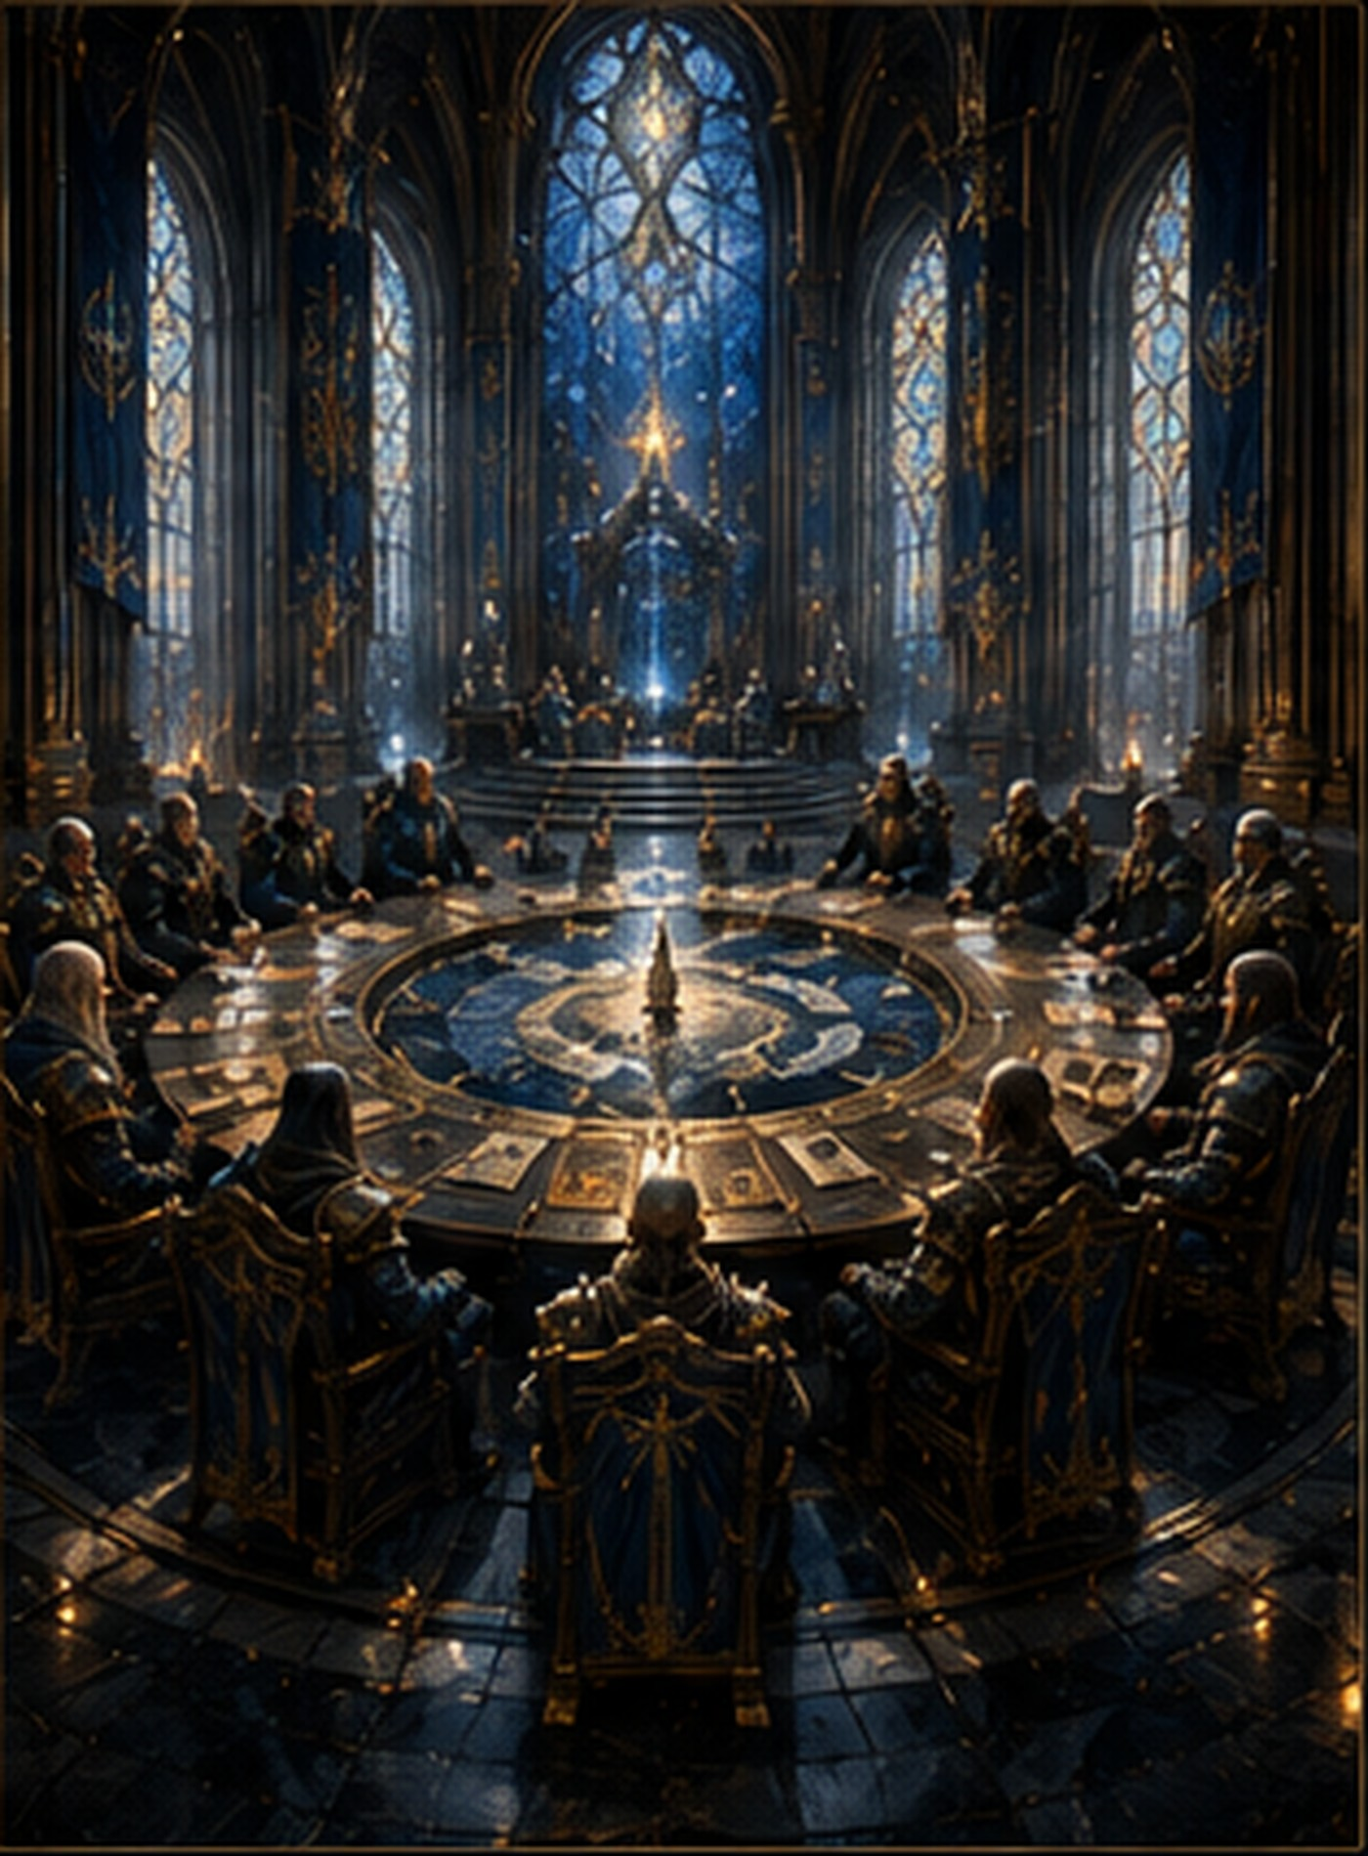
At the center of the Citadel stood a circular chamber built around a map of Valekor. Seats surrounded the map without throne or elevated platform. The founders designed the room so no voice could stand above another.
Humans represented the surviving kingdoms. Elven envoys carried knowledge of ancient magic. Dwarven smiths protected the secrets of celestial steel. Keepers preserved the histories of extinct cultures. Guardians, when any remained, served as defenders rather than rulers.
The Council of Light had one purpose: prevent fear from dividing the free peoples before the Shadow King arrived. Its first decision after the awakening was unanimous. The five chosen would be trained together, regardless of origin, title, or bloodline.

Chapter IV - The Hall of Heroes
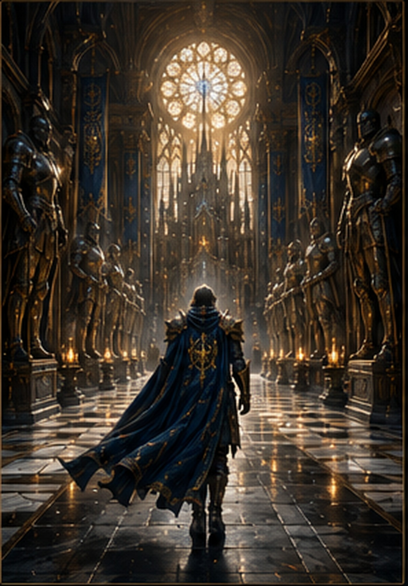
The Hall of Heroes preserved more than statues. Each monument contained a memory crystal holding a moment from the life of a fallen defender. Visitors could witness victories, mistakes, promises, and final sacrifices.
The Last Guardian had once walked this hall as an apprentice. His place among the statues remained empty, because the Citadel's keepers believed his story had not ended.
The five chosen entered separately. Each emerged changed. They learned that heroism was not the absence of fear, but the decision to move forward while carrying it.

Chapter V - The Awakening of the Five
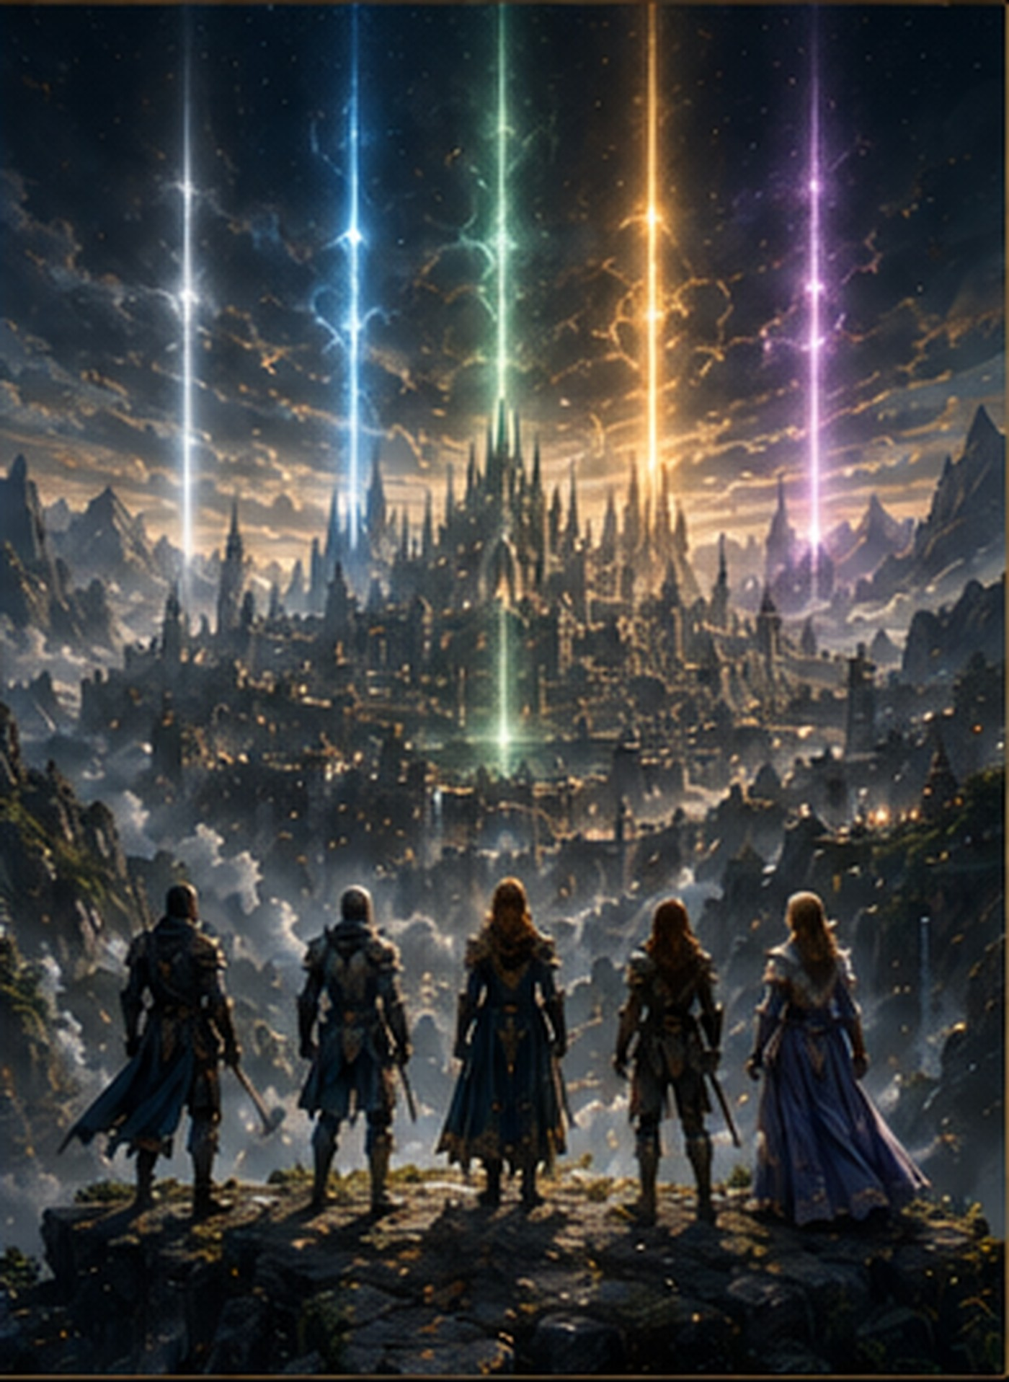
Five beams rose from distant corners of Valekor: blue from the frozen north, green from the ancient forests, gold from the western mountains, violet from the ruins of the first mages, and white from a village with no recorded name.
The chosen did not share a race, kingdom, profession, or history. One was a soldier who had abandoned war. One was a healer who feared taking a life. One was a thief who had never trusted anyone. One was a scholar whose knowledge had failed to save her family. The fifth arrived without memories.
The Eternal Flame had not selected the strongest. It had chosen those capable of becoming something greater together.

Chapter VI - Beneath the Citadel
Below the public halls stretched an older structure predating the fortress. Its corridors contained sealed doors, dormant machines, and inscriptions written in the language of the first Guardians.
At the lowest level, the five discovered a chamber shaped like a dragon's heart. Five empty sockets surrounded a central altar. When they approached, the sockets began to glow.
The Citadel had not merely awaited new defenders. It had been built for them.

Chapter VII - The First Warning
During the first night of training, every flame in the eastern tower turned black. Scouts reported movement beyond the Ashen Pass. Birds abandoned the sky. The wards surrounding the valley weakened for exactly fifty heartbeats.
A message appeared across the Council map in burning red letters: I HAVE FOUND YOU.
The Shadow King knew the Citadel had awakened. The Final War was no longer a prophecy. It had become a countdown.

Sacred Architecture
The Sacred Citadel is divided into seven major districts: the Celestial Gates, the Council Ring, the Hall of Heroes, the Archive Towers, the Healing Gardens, the Sky Forges, and the Guardian Keep.
Every district can operate independently during a siege. Hidden bridges connect the towers, while water channels carry power and supplies throughout the mountain. The central beacon can send a signal visible across all of Valekor when the free kingdoms are called to war.

Key Characters
The Last Guardian - The final surviving master of the old Guardian Order.
The Five Chosen - A new generation selected by the Eternal Flame.
High Keeper Seralyne - Guardian of the Citadel archives and leader of the Council of Light.
Forge-Lord Dhoran - Master of celestial steel and commander of the western defenses.
The Shadow King - The ancient enemy whose armies now march toward the Citadel.

Relics and Symbols
The Beacon of Unity - A crystal tower that links the Citadel to every surviving free kingdom.
The Five Seals - Dormant artifacts beneath the Guardian Keep, each responding to one chosen heir.
The Council Map - A living representation of Valekor that reveals corruption, movement, and broken wards.
The Citadel Crest - A golden spear enclosed by wings, symbolizing defense without conquest.

Developer Notes
Developer Library 051 moves Valekor from the solitary legend of the Last Guardian into an ensemble story. The Sacred Citadel becomes the narrative center of the Final War arc and the primary meeting point for future heroes, factions, relics, and conflicts.
The next document introduces the identities, abilities, fears, and hidden connections of the five chosen heirs.

Next Document - 052 The Five Chosen
The Eternal Flame never chooses by strength alone. In Document 052, the five heirs begin their training and discover that one of them carries a connection to the Shadow King.

