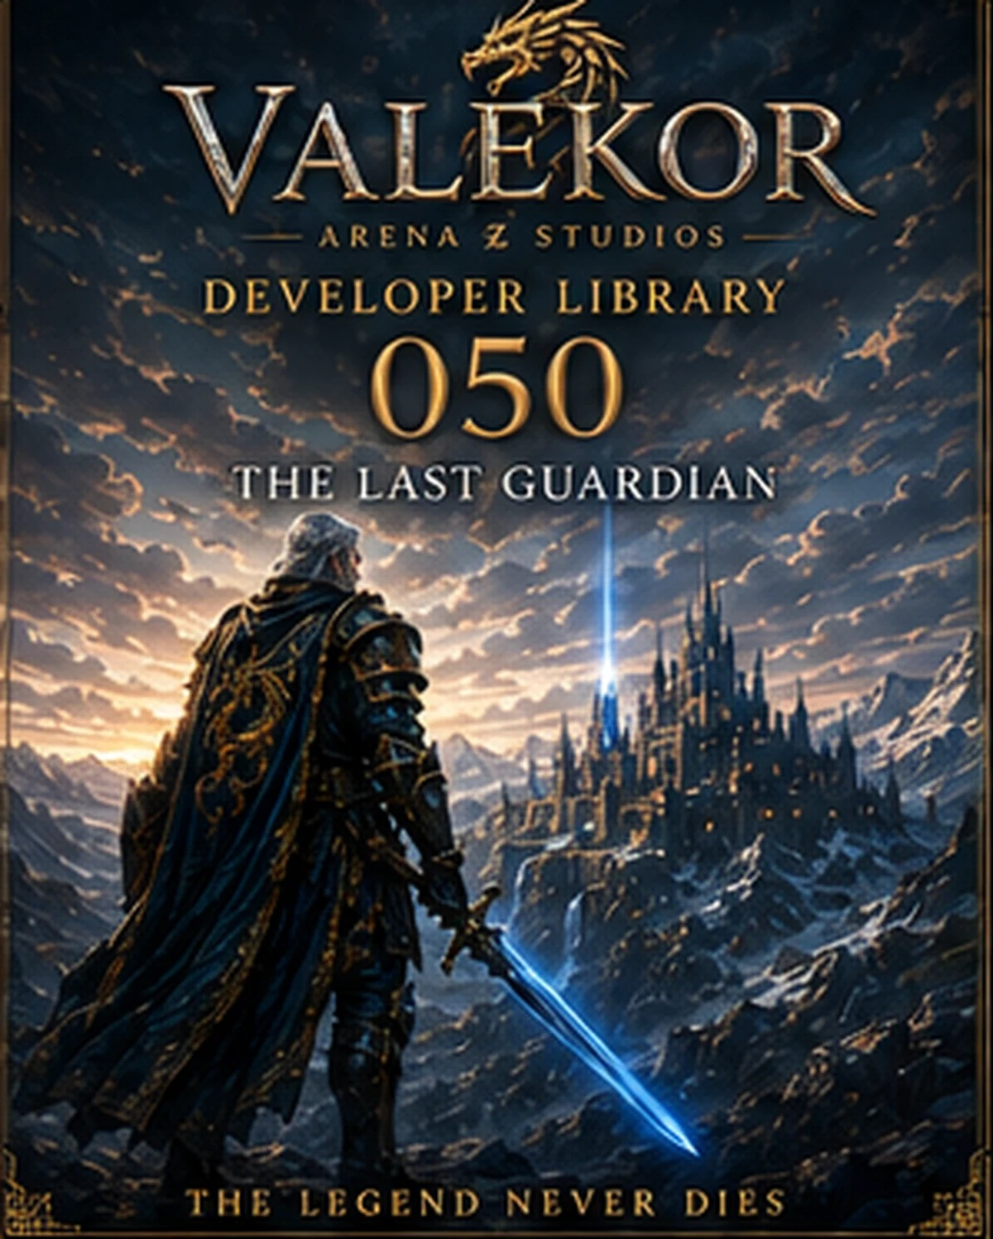

VALEKOR
DEVELOPER LIBRARY 050
THE LAST GUARDIAN

Official Synopsis
For one thousand years, the world believed the Guardian Order had disappeared forever. In the frozen mountains of the north, a single warrior continues to protect the Eternal Flame. As an ancient darkness awakens, forgotten relics answer the light and a new generation is called. The future of Valekor no longer depends on one Guardian alone.
A Guardian does not fight because victory is certain. A Guardian fights because hope must never disappear.
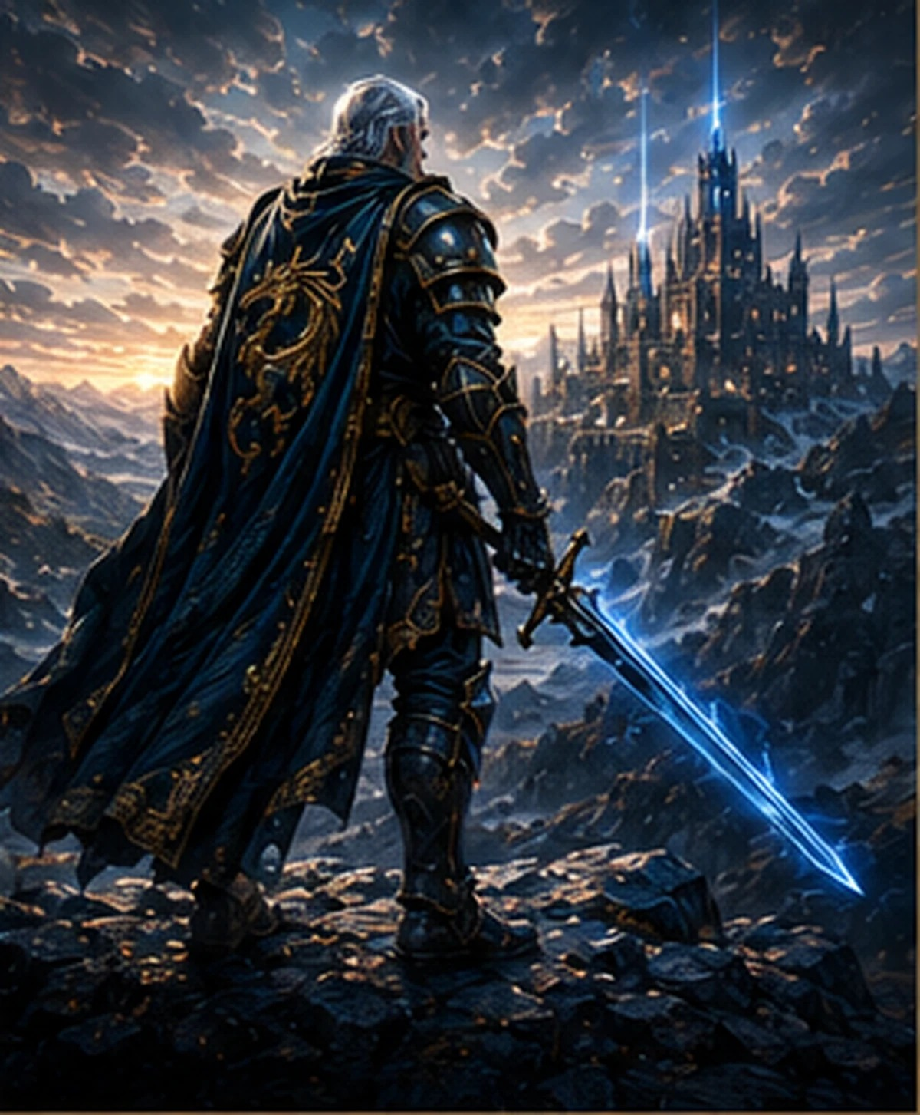

Contents
01. Prologue - The Oath That Survived
02. The Last Guardian
03. Hall of Eternal Memories
04. Sanctuary of Eternity
05. The Eternal Flame
06. The Shadow King
07. The Guardian Order
08. Relics of the Final Watch
09. The Last Watch
10. Epilogue - The Return of Hope

Prologue - The Oath That Survived
For a thousand years, Valekor believed the Guardian Order had vanished. Kingdoms rose over its ruins, roads crossed forgotten battlefields, and the old vows became stories for children. Yet beyond the northern mountains, one warrior continued his watch. He guarded the Eternal Flame, the last light capable of awakening the ancient defenses of the world.

The Last Guardian
His true name was surrendered when he received the Dragon Crest. He became a title, an oath, and a living boundary between the free kingdoms and the darkness waiting beneath the earth. His armor bears the scars of the Great War, while the Sword of Azure Flame still answers to his hand.

Hall of Eternal Memories
Within the Sanctuary stands a silent hall lined with statues of fallen Guardians. Each statue preserves a fragment of memory: victories, failures, final commands, and sacrifices. The empty pedestal at the center was prepared for the final member of the Order, but the Last Guardian refuses to let his story end while Valekor remains in danger.
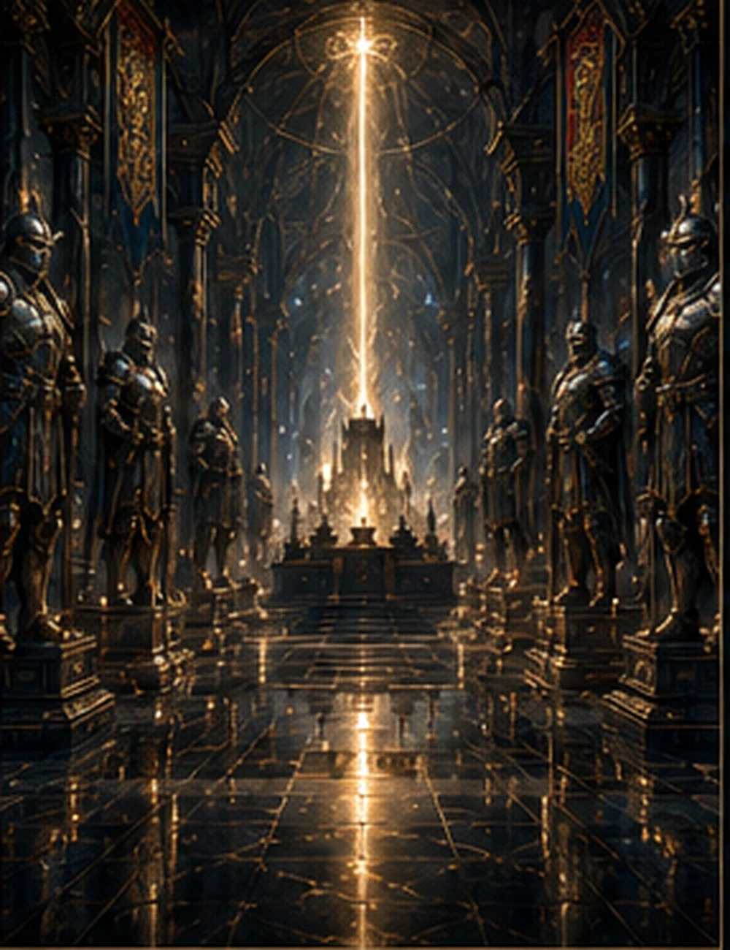

Sanctuary of Eternity
Built into the frozen mountains, the Sanctuary is fortress, archive, temple, and refuge. Its bridges cross bottomless ravines; its towers gather celestial energy; and its sealed chambers contain maps of lost kingdoms, dragon records, and weapons forged before the first crown of Valekor.
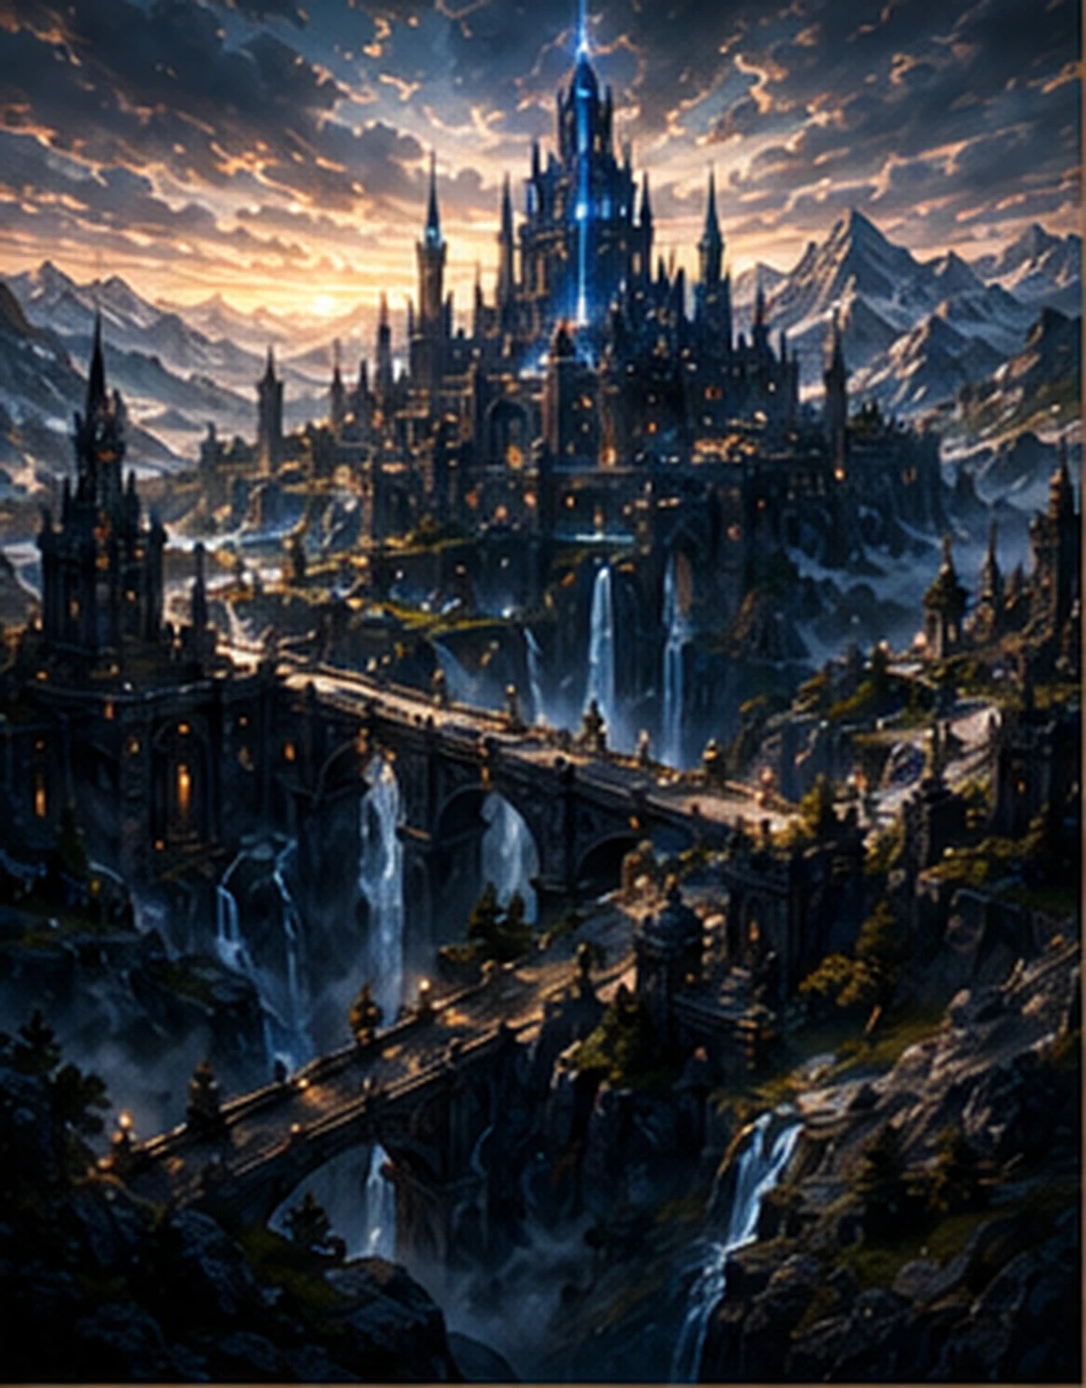

The Eternal Flame
The blue fire at the heart of the Sanctuary is not ordinary flame. It is a living force connected to every sacred relic created by the Guardian Order. When darkness grows, the flame becomes brighter. When hope disappears, it searches for new bearers.
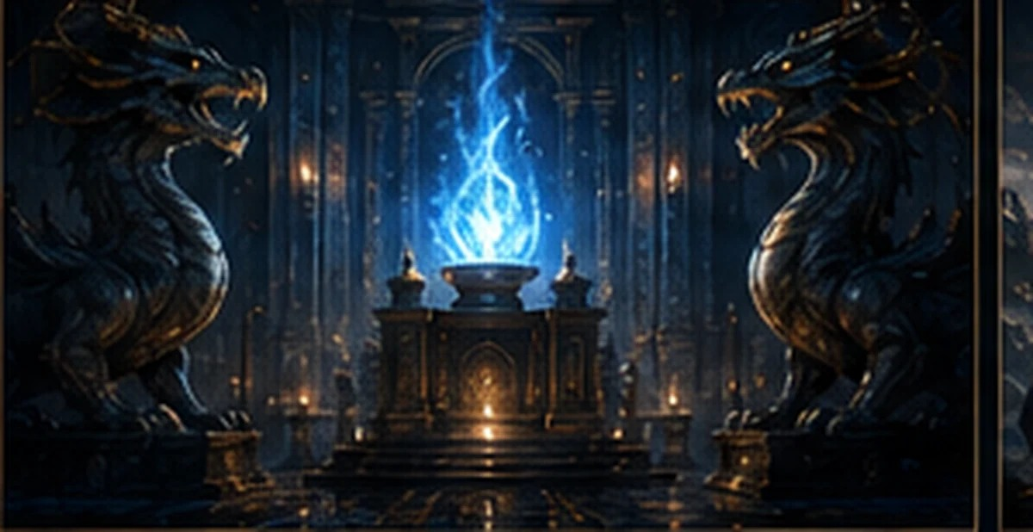

The Shadow King
The Shadow King did not return as a mortal ruler. He returned as a will moving through ruined armies, corrupted dragons, and forgotten grief. His legions seek one purpose: extinguish the Eternal Flame before it can awaken the next generation of Guardians.
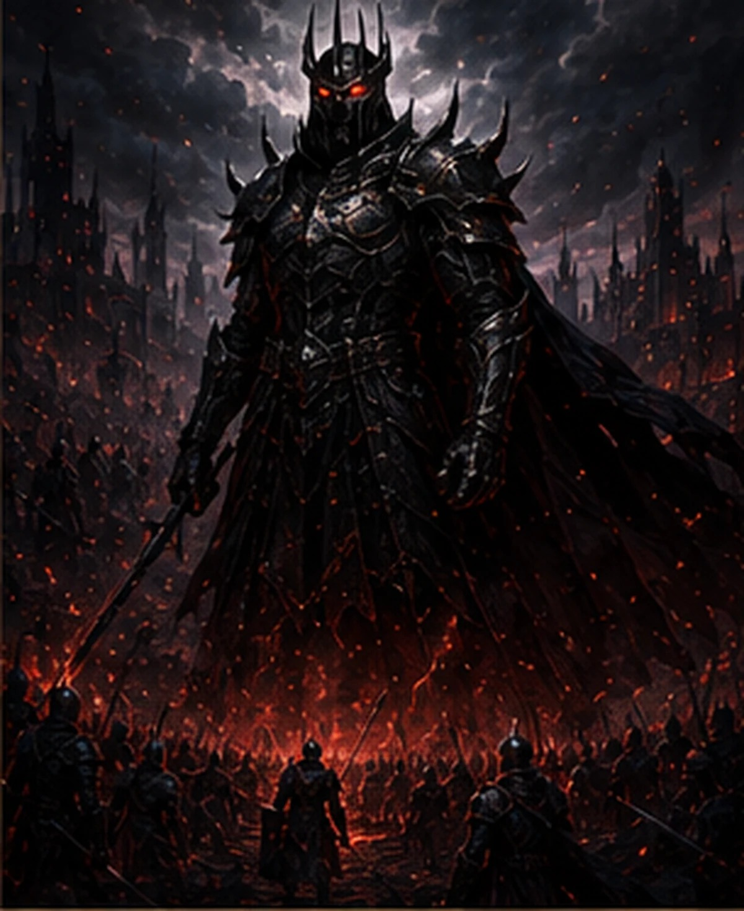

The Guardian Order
The Order was founded on four sacred pillars: courage without pride, strength without cruelty, knowledge without domination, and sacrifice without expectation of glory. Its members defended people they would never meet and preserved truths the kingdoms often wished to erase.
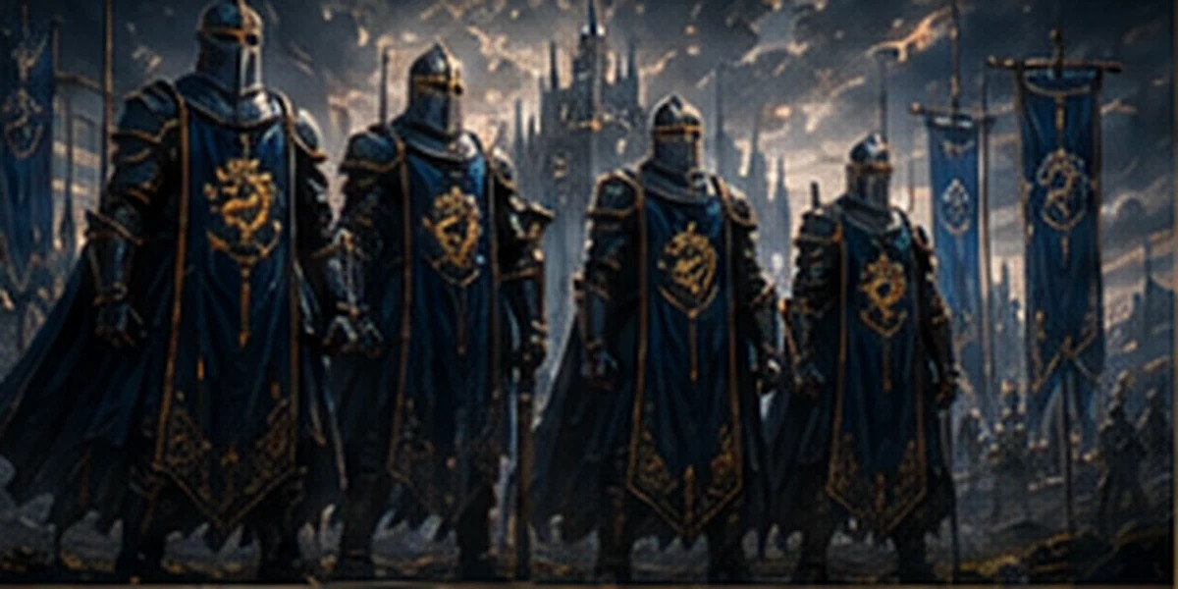

Relics of the Final Watch
The Dragon Crest Shield carries the symbol of the first pact between humanity and the ancient dragons. The Sword of Azure Flame channels the living fire of the Sanctuary. Together, they identify the Last Guardian as protector of the final gate.
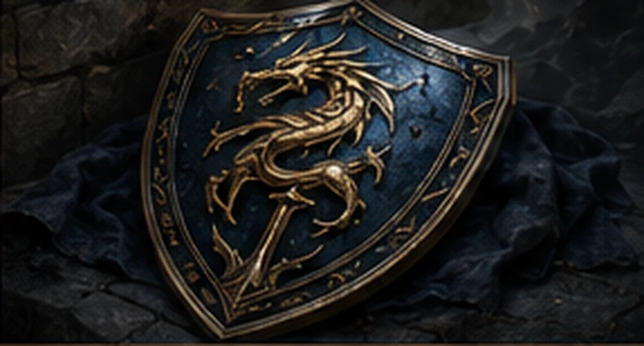

The Last Watch
Each dawn he walks the same path: the Eternal Flame, the Hall of Memories, the northern wall, and the bridge of the Sanctuary. After one thousand years, the routine changes. Five beams of blue light leave the flame and travel toward distant lands. The next Guardians have been chosen.
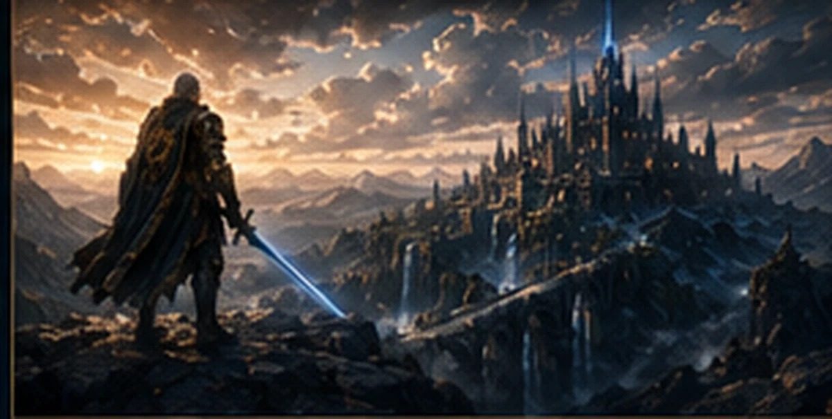

Epilogue - The Return of Hope
The Last Guardian understands that his purpose was never to fight alone forever. His duty was to keep the light alive until others could answer it. Document 050 closes the first great arc of Valekor and opens the path to Developer Library 051: The Sacred Citadel.

Official Timeline
0 AE - The Eternal Flame appears.
87 AE - The Seven Wanderers unite.
90 AE - The Guardian Order is founded.
820 AE - The Great War begins.
871 AE - The Order falls.
872 AE - The Last Guardian begins his watch.
1872 AE - The Eternal Flame awakens.

Developer Notes
Developer Library 050 closes the first great narrative arc of Valekor. It establishes the Last Guardian as the bridge between the lost Guardian Order and the heroes who will emerge in Developer Library 051 - The Sacred Citadel.
Every legend ends so another can begin.

