DEVELOPER LIBRARY 049
THE SHADOW KING
Arena Z Studios | Valekor Master Project
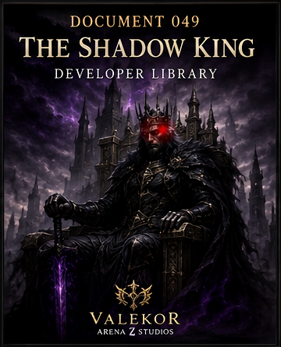
"The brightest flame casts the darkest shadow."

I. The First Crown
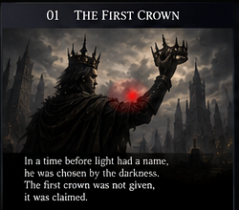
Before the kingdoms of Valekor learned the language of light, a sovereign rose from the age of nameless darkness. His crown was not inherited or blessed. It was forged from conquered wills, sealed in shadow, and claimed by force. The ruler who wore it became known only as the Shadow King.

II. The Kingdom of Ashes
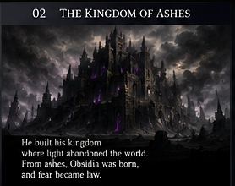
He built his dominion where the world had been abandoned. Towers of black stone rose from fields of ash, and every road led toward a throne that consumed hope. His kingdom did not ask for loyalty. It demanded surrender.

III. The Legion of Shadows
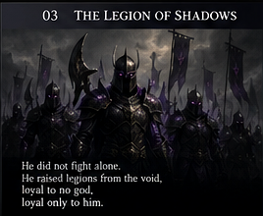
The Shadow King did not march alone. From the void he raised a legion without names, banners, or mercy. They served no god and carried no dream of glory. Their purpose was simple: extinguish every flame that might guide Valekor toward freedom.

IV. The War Against Light
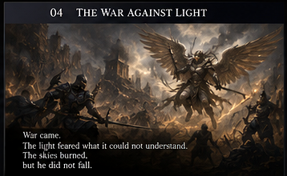
When the guardians of Valekor gathered around the Eternal Flame, war became unavoidable. The skies burned above the old kingdoms. Temples fell, armies vanished, and the world learned that light could be wounded even when it could not be destroyed.

V. The Fall of the Shadow King
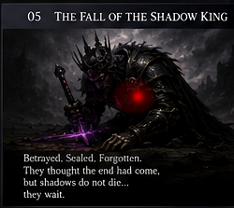
At the height of his power, betrayal opened the path to his defeat. The Shadow King was sealed beyond the borders of the living world. His throne shattered, his crown disappeared, and his name was forbidden. Yet shadows do not die. They wait.

VI. The Whispers
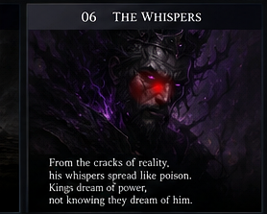
Centuries later, whispers began moving through ruined halls and forgotten dreams. Kings heard promises of power. Warriors saw red eyes watching from the dark. Each whisper carried the same message: the first crown still remembers its master.

VII. The Prophecy
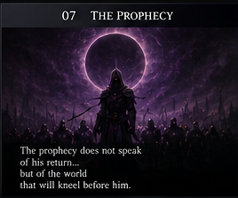
The prophecy does not speak of his return alone. It speaks of a world divided, of guardians weakened, and of the Eternal Flame forced to reveal its final secret. The Shadow King will rise when Valekor believes the darkness has already been defeated.

VIII. The Return
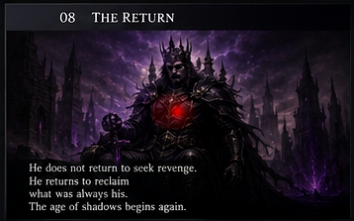
He does not return seeking revenge. He returns to reclaim what he believes was always his: the throne, the crown, and the destiny of Valekor. When his red eyes open beneath the eclipse, the age of shadows begins again.

Continuity
- 046 - The Guardians of the Arena
- 047 - The Seven Trials
- 048 - The Eternal Flame
- 049 - The Shadow King
Official website: https://arenazreborn.netlify.app/

