DEVELOPER LIBRARY 048
THE ETERNAL FLAME
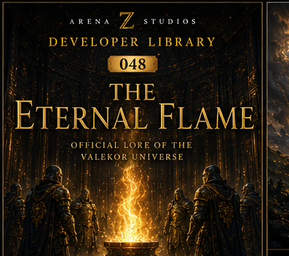
Official Lore of the Valekor Universe

Overview
Long before kingdoms rose, before the Grand Arena was built, and before the first Guardian carried the Golden Shield, there was only light. From that light was born the Eternal Flame: life, memory, hope, and destiny itself.

Chapter 1: The Fall of the Star
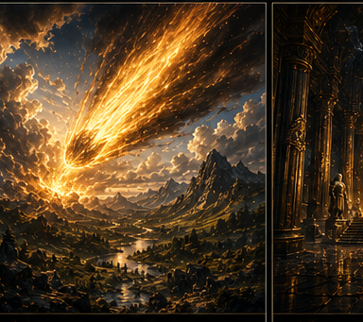
Thousands of years ago, the sky split open. A brilliant celestial star descended through the heavens. When it struck the earth, the mountains trembled, the oceans answered, and the skies became gold. From the impact emerged a fire that consumed nothing yet illuminated everything. The ancient tribes named it the Eternal Flame.

Chapter 2: The Temple of Light
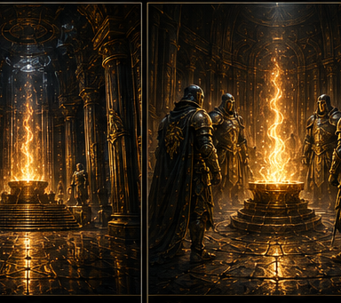
The First Builders understood that the Flame could not remain exposed. Around it they constructed an enormous underground sanctuary of golden pillars, endless halls, and walls engraved with forgotten languages. The Temple became the holiest place in Valekor.

Chapter 3: The Keepers of the Flame
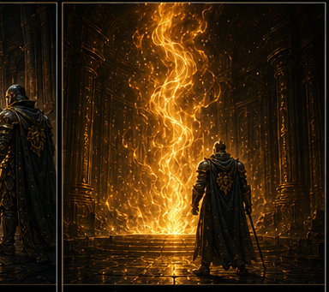
A special Order was created to protect the Flame. They abandoned families, titles, wealth, and even their names. History remembers them simply as the Keepers.

Chapter 4: The Living Fire
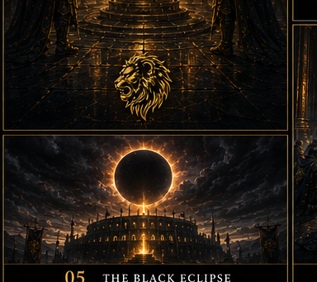
The Flame possesses a consciousness. It watches, remembers, and judges. Those driven by greed feel unbearable heat. The corrupt cannot approach. Only souls with true balance may stand before it.

Chapter 5: The Black Eclipse
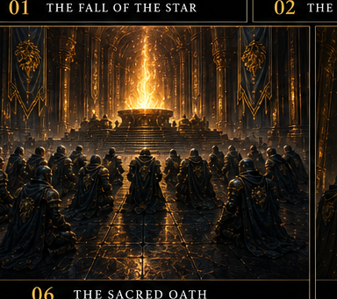
Once every thousand years, the Flame weakens. Dark clouds consume the sky, the stars disappear, and shadows awaken beneath the earth. Every Guardian prepares for this day because if the Flame dies, Valekor dies.

Chapter 6: The Sacred Oath
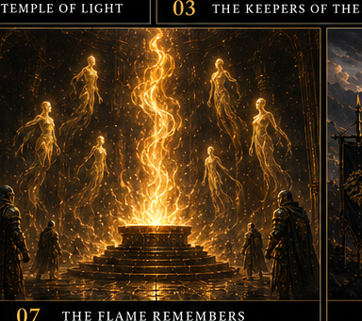
Every Guardian kneels before the Flame only once and swears that life, strength, honor, and soul belong to Valekor and the Eternal Flame. Those who betray the oath lose the Guardian Mark forever.

Chapter 7: The Flame Remembers
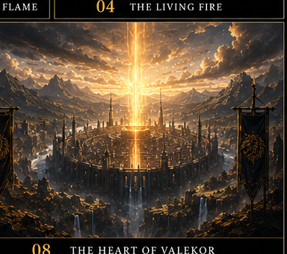
No Guardian truly dies. When a Guardian falls, the spirit returns to the Flame. Memories become light, courage becomes warmth, and sacrifice strengthens future generations.

Chapter 8: The Heart of Valekor
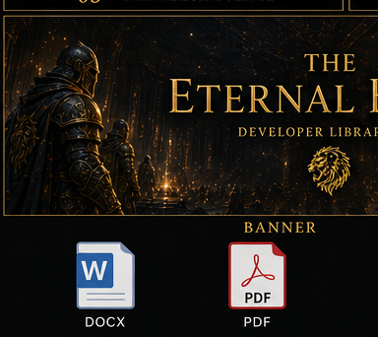
Without the Eternal Flame, the Arena loses its purpose, the Guardians lose their strength, and the kingdoms lose hope. The Flame is not simply protected. It protects everyone.

Legacy
Every civilization eventually disappears. Every king is forgotten. Every empire falls. But the Eternal Flame remains - waiting, watching, and remembering. As long as its light survives, so does the dream of Valekor.
Empires are built by kings. Legends are remembered by the Flame.

