DEVELOPER LIBRARY 047
THE SEVEN TRIALS
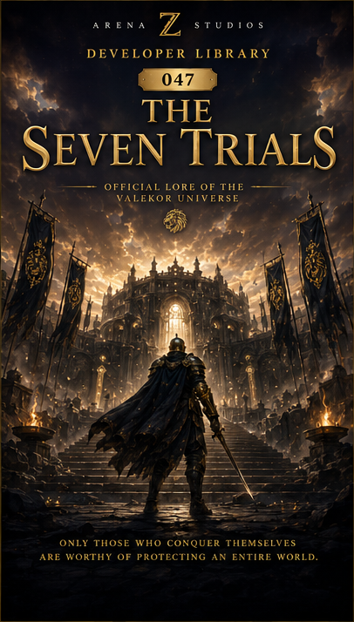
"Only those who conquer themselves are worthy of protecting an entire world."
ARENA Z STUDIOS
Official Lore of the Valekor Universe

Overview
No warrior became a Guardian through birth, wealth, reputation, or command. Every Guardian earned a place in the Order by surviving the Seven Trials. These were not simply tests of combat. They were designed to reveal character, discipline, mercy, wisdom, and the ability to protect Valekor without being corrupted by power.

1. Trial I - The Trial of Courage
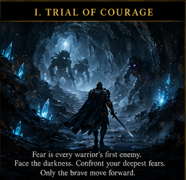
Fear is every warrior's first enemy.
Candidates entered the Caverns of Echoes alone, where darkness transformed memory into terror. The walls whispered with the voices of past failures, and shadow-born creatures took the form of each candidate's deepest fear.
The trial could not be defeated by strength. A candidate passed only by continuing forward while afraid. Courage, the Guardians taught, was not the absence of fear, but the decision that duty mattered more.

2. Trial II - The Trial of Wisdom
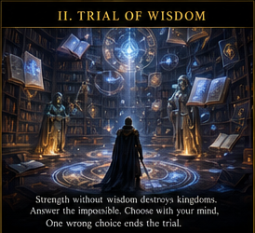
Strength without wisdom destroys kingdoms.
Inside the Library of Ages, candidates faced ancient riddles, moral dilemmas, and visions of possible futures. Every choice carried consequences, and no answer could be reached by force.
The trial measured patience, judgment, and the ability to protect many lives without losing compassion for one.

3. Trial III - The Trial of Sacrifice
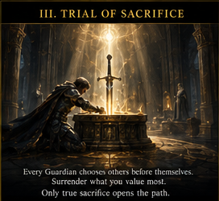
Every Guardian must be prepared to place others before themselves.
Each candidate was asked to surrender the possession, ambition, or bond they valued most. Some offered weapons. Others abandoned titles, wealth, or the promise of personal glory.
The altar accepted no false sacrifice. Only those who released their greatest attachment without resentment were allowed to continue.

4. Trial IV - The Trial of Unity
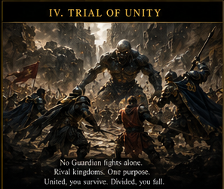
No Guardian fights alone.
Candidates from rival kingdoms were placed together against impossible odds. Old grudges, pride, and distrust became more dangerous than the enemies surrounding them.
The trial ended only when every survivor understood that unity was not agreement, but the discipline to protect one another despite difference.

5. Trial V - The Trial of Honor
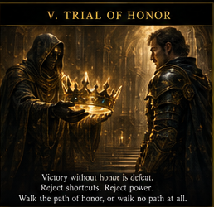
Victory without honor is defeat.
A mysterious figure offered each candidate shortcuts, forbidden power, and immediate recognition. The bargain promised success without sacrifice.
Those who accepted failed instantly. Those who refused learned that a Guardian's greatest battle is often the temptation to betray the values they claim to defend.

6. Trial VI - The Trial of Endurance
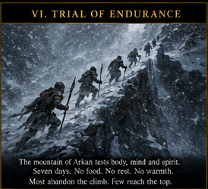
The mountain of Arkan tested body, mind, and spirit.
For seven days the candidates climbed through blizzards, hunger, exhaustion, and isolation. The path offered many safe places to turn back.
Endurance was not measured by speed. It was measured by the ability to continue when no audience remained and no reward was visible.

7. Trial VII - The Trial of the Lion
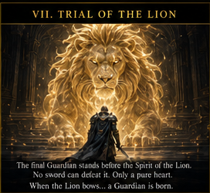
The final candidate stood before the Spirit of the Golden Lion.
No sword could wound it. No shield could contain it. The Lion looked beyond armor and reputation into the truth of the heart.
Only a warrior free from cruelty, vanity, and hunger for domination received its blessing. When the Lion bowed, a new Guardian was born.

8. The Guardian's Mark
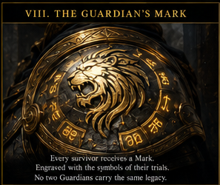
Every survivor received a unique mark engraved into celestial steel.
The symbols recorded the choices made during the trials rather than simple victories. No two marks were identical because no two candidates walked the same inner path.
The mark could never be removed. It became a permanent record of the Guardian's promise to Valekor.

9. The First Ceremony
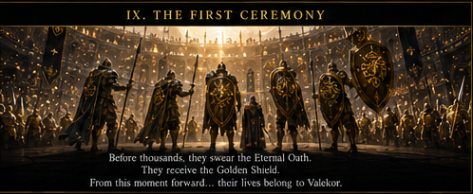
Upon returning to the Grand Arena, the survivors entered the Hall of Guardians before thousands of witnesses.
They swore the Eternal Oath, received the Golden Shield, and surrendered their former military rank. From that moment onward, their lives belonged to Valekor.
The ceremony ended when the Eternal Flame reflected across every shield, symbolizing one Order formed from many kingdoms.

10. Legacy of the Seven Trials
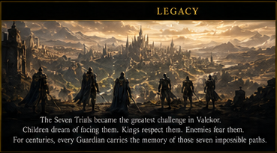
The Seven Trials became the greatest challenge in Valekor.
Children dreamed of facing them. Kings respected those who survived them. Enemies feared the discipline they created.
For centuries, every Guardian carried the memory of seven impossible paths - not as proof of superiority, but as a reminder that power must first conquer itself.

A SWORD CREATES WARRIORS.
SEVEN TRIALS CREATE GUARDIANS.
Arena Z Studios
Developer Library 047

