DEVELOPER LIBRARY 046
THE GUARDIANS OF THE ARENA
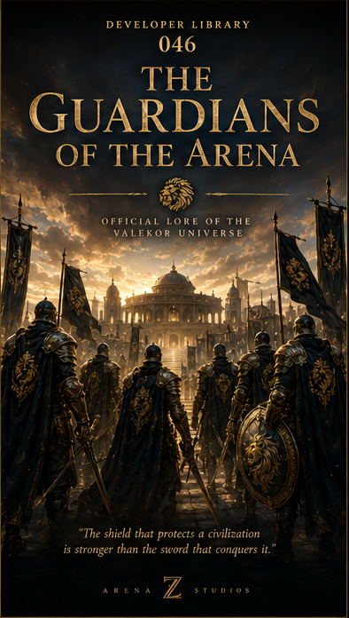
"The shield that protects a civilization is stronger than the sword that conquers it."
ARENA Z STUDIOS
Official Lore of the Valekor Universe

Overview
Long before the Grand Arena became a symbol of peace, an elite order was created to protect it from those who sought to corrupt its purpose. They became known as the Guardians of the Arena. Neither kings nor conquerors could command them. Their loyalty belonged only to Valekor.

1. The Birth of the Guardians
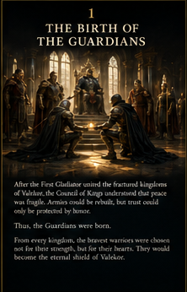
After the First Gladiator united the fractured kingdoms, Valekor entered an age of fragile peace. The rulers understood that treaties alone could not protect the Grand Arena, the sacred archives, or the citizens who had survived generations of war.
From every kingdom, warriors were summoned. They were not chosen only for strength, rank, or victory. They were chosen for discipline, compassion, courage, and the willingness to stand between danger and the innocent.
Thus, the first Guardian Order was formed. Its members abandoned personal banners and swore loyalty to Valekor as a whole.

2. The Eternal Oath
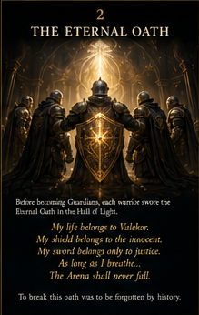
Before becoming Guardians, every initiate stood in the Hall of Oaths and placed one hand upon the Golden Shield.
"My life belongs to Valekor. My shield belongs to the innocent. My sword belongs only to justice. As long as I breathe, the Arena shall never fall."
The oath was not a ceremonial promise. It defined every decision a Guardian would make. To abandon the oath was to lose rank, name, and place in the history of the Order.

3. The Golden Shield
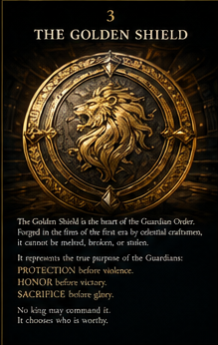
The Golden Shield became the heart of the Guardian Order. Forged in the fires of the First Era, it carried the Lion Crest, a symbol of courage controlled by wisdom.
The shield represented protection before violence, honor before victory, and sacrifice before glory. No king could command it, and no conqueror could claim it.
A Guardian earned the right to carry the Lion Crest only after proving that power would never be placed above duty.

4. Duties of the Guardians
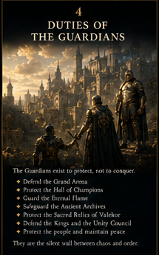
The Guardians existed to protect, never to conquer. They defended the Grand Arena, the Hall of Champions, the Eternal Flame, the ancient archives, sacred relics, and the Unity Council.
They escorted civilians through dangerous territories, prevented conflicts between kingdoms, and protected the weak when rulers failed to act.
Their presence became a silent wall between Valekor and chaos.

5. The Hall of Guardians
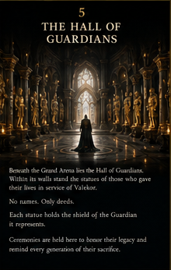
Beneath the Grand Arena lies the Hall of Guardians, a vast chamber of black stone, gold fire, and towering statues.
Every statue honors a Guardian who gave everything in service to Valekor. No names are engraved upon the stone. The Order teaches that deeds outlive titles.
Ceremonies are held beneath these silent figures so each new Guardian remembers the weight of the shield they inherit.

6. Guardian Armor
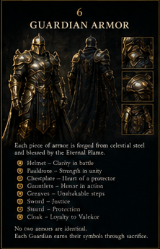
Guardian armor was forged from celestial steel and tempered beside the Eternal Flame. Each suit was built for endurance, protection, and unity of movement.
The helmet symbolized clarity in battle. The breastplate represented strength in unity. The gauntlets represented service. The greaves marked the path of duty. The sword stood for justice, while the shield remained the highest symbol of protection.
No two suits were identical. Every Guardian earned personal markings through sacrifice and service.

7. The Seven Trials
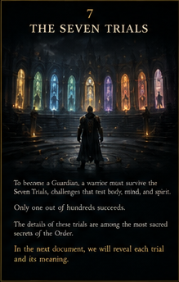
No warrior could join the Order by reputation alone. Every candidate faced seven trials designed to test body, mind, discipline, loyalty, mercy, courage, and spirit.
Only a small number survived the complete journey. Those who succeeded were forever changed.
The full meaning of each trial will be revealed in Developer Library 047: The Seven Trials.

8. The Eternal Flame
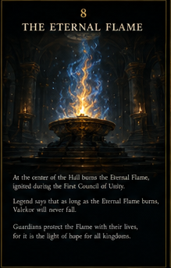
At the center of the Hall burns the Eternal Flame, ignited during the First Council of Unity.
Its blue and golden fire has never been extinguished. Legends say that as long as the flame burns, the spirit of Valekor cannot be conquered.
Guardians protect the flame with their lives, for it is both a sacred symbol and a living reminder of the peace they defend.

9. Guardians of Peace
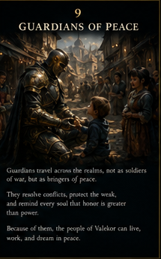
The Guardians traveled across kingdoms not as soldiers of war, but as bringers of peace.
They resolved disputes, protected villages, escorted healers, and reminded rulers that authority without responsibility would destroy the unity of Valekor.
Children saw them as heroes. Citizens saw them as protectors. Even kings learned to respect the shield.

10. Legacy of the Guardians
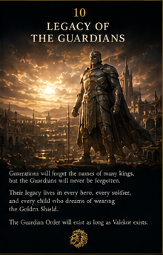
Generations would forget the names of many rulers, but the Guardians remained part of every legend.
Their legacy lived in every hero who defended the powerless, every soldier who refused a dishonorable command, and every child who dreamed of carrying the Golden Shield.
As long as Valekor exists, the Guardian Order will stand between hope and destruction.

EMPIRES ARE BUILT BY KINGS.
LEGENDS ARE PROTECTED BY GUARDIANS.
Arena Z Studios
Developer Library 046

